Scale Drawings
10 cm

2.5cm
5 cm
A kitchen designer wants to show some wall tile designs to customers. The actual size of the tile is 10 cm x 10 cm (100 cm ²). The designer wishes to scale down the designs to put in a book. The designer is unsure whether to scale down his designs 1:2 (1 cm in the drawing equals 2 cm in real life) or 1:4 (1cm in the drawing equals 4cm in real life).

Now create your own tile designs and draw these in a 1:2 and 1:4 scale!

Real Life Examples of scale drawings

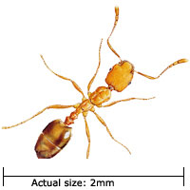

1:12 scale (approx. 38cm / 15.0in long) Bugatti Veyron 16.4 (Production Version) in Red and Black (1:12 scale by AUTOart 12531)
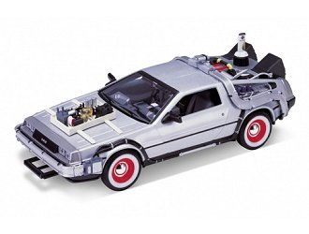

De Lorean LK (Back To The Future Part 3) in Silver

(1:24 scale (approx. 17cm)
This diecast model De Lorean LK (Back To The Future Part 3) is Silver and features working wheels.
1:24 scale (approx. 17cm / 6.7in long) - made by Welly.




Scale drawing. Decrease Bart using a scale of 1:2



Scale drawing. Decrease the Goomba using a scale of 1:2

Scale drawing. Enlarge Stewie on a scale of 2:1



Scale drawing. Enlarge Olympic Logo using a scale of 4:1

